JASAL Journal Submission Guidelines:
Title in Title-Case, 14-point, Bold, Times New Roman Font, Centered

Running head (Maximum 50 characters, including spaces, shortened title):
JASAL Journal Submission Guidelines

Author 1 (Given Middle Family)
Affiliation
Email Address

Author 2 (Given Middle Family)
Affiliation
Email Address (If desired)

Author Biography
Do not use any titles or degrees (e.g., Dr., PhD, Professor). Each author of the paper should have a brief bio of less than 50 words. This should be written in the third person. Single space and use Times New Roman font, 12 point. Do not indent. Flush left. Do not justify.

(Insert a page break directly after the last bio.)

Abstract
Your English abstract goes here. The English abstract should be 250 words (or less). Japanese abstract 500 characters or less. Single space and use Times New Roman font, 12 point, for English and MS Mincho, 12 point, for Japanese. Do not indent. Flush left. Do not justify.

日本語の要約をここに書いてください。日本語の要旨は500字以下でなければなりません。英語の要旨は250 語以下です。 シングルスペースで書き、英語はTimes New Roman、12ポイント、日本語はMS明朝の12ポイントを使用します。インデントせず、左揃えにしてください。

Keywords: write up to five keywords

(Insert a page break after the keywords)

Begin the article here. Indent paragraphs 12.7 mm (.5 inch). In APA, there is no header that says Introduction. The word limit for the article is 5000 words. This does not include the Title, Abstracts, Author Bio or Bios, References, or the Appendices.

Format Details
The manuscript should be formatted for A4-size paper, using one and a half (1.5) line spacing, 12 point Times New Roman font. Use “Normal” paragraph style for all text (select format type from the left hand side of your toolbar on Word). Do not include extra lines between paragraphs. All margins should be set for 25.4 mm (1 inch). Save the manuscript as a Microsoft Word document, and name it with author surnames (Author1_Author2.docx).
All manuscripts should be left-justified. Please insert only one space after a period at the end of sentences. As you format, click ¶ from the toolbar on Word to show formatting. Overall formatting should follow the guidelines listed in the Publication Manual of the American Psychological Association (APA) 7th Edition.
Headings
Center level 1 headings. Left-justify level 2 and 3 headings. For all headings, use title case (capitalize the initial letter of each word, except articles, prepositions, and conjunctions) and bold text.
Level 1 and Level 2 Headings
Level 1 headings might include Methods, Findings, and Discussion, or other headings such as The Self-Directed Learning Project or Student Worker Experiences. The level 2 headings are for sub-themes. If you use level 2 headings, there should be at least two of them under a level 1 heading.
Using Level 3 Headings
There should be at least two level 3 headings under a level 2 heading if you use them.
Other Stylistic Points
Self-access is always hyphenated. Japanese words should be in modified Hepburn (Shūsei Hebon-shiki) and placed in italics.

Tables and Figures
Please include all tables and figures in the article itself.
Tables
Tables should have a title that is written in title case, with the first letter of the content words of the table title capitalized (see Table 1).

Table 1
Students’ Reasons for Visiting the SAC (N = 200)

Reason | Example quote | Frequency, n (%)
Friendship | “I want to see my friends. It’s where we hang out” | 90 (45%)
Study support | “I needed help with my assignment” | 80 (40%)
Refreshments | "I always get a coffee” | 50 (25%)
Event | “There was a Christmas party” | 50 (25%)

Statistical Tables
Commonly used statistical abbreviations such as mean (M) and standard deviation (SD) do not need to be explained; however, for less well-known abbreviations, include a note at the bottom of the table.
Word Tables
Word tables follow the same format as statistical tables; i.e., there should be no vertical lines.
Figures

Figures should be included in the. Give the figure a title, in title case, left-justified.
All figures should be accessible to people with color-vision deficiency (color blindness). For more information, please refer to the APA Style website.

Figure 1
Center Users

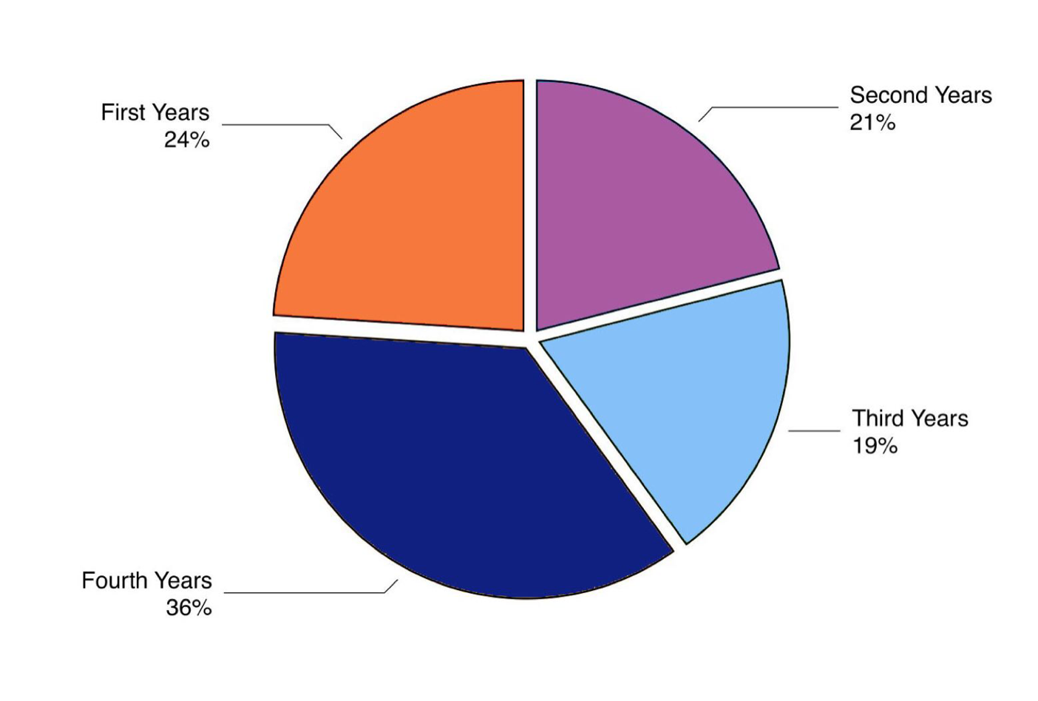
Photos and Illustrations

Because JASAL Journal will be published electronically, we are able to include photos and illustrations. However, it is the author’s responsibility to secure all rights and permissions and ensure that the use of the photos and illustrations does not violate copyright.

Photographs should be high quality, in TIFF format. Please do not scan laser printouts of figures and send them as digital files. Screenshots should be in PNG format. All graphics should be submitted at their intended publication size so that no reduction or enlargement is necessary.

Notes
If you have supplementary information to convey, you can do so in an endnote. Each endnote should contain just one idea. Number the notes consecutively, using superscript numbers. Do not use footnotes.

Acknowledgments
Acknowledgments, if any, should be placed at the end of the text after the Notes and before References. These should be in italics. Do not acknowledge the editors.

References
References should have hanging indentation. Use the en dash (not a hyphen) between page ranges (180–190, not 180-190). Include a Digital Object Identifier (DOI) when available. If there is no DOI, include a URL, if applicable (for a publicaly available website).
To find DOIs for sources, go to: https://doi.crossref.org/simpleTextQuery. Paste reference entries into the box, select “List all possible DOIs per reference”, and “Submit”. Paste the DOI as a URL, and include a hyperlink. All links should be active, black font, no underline.
For sources written in a language other than English, include the title in the original language (Romanized). The translation of the title then goes in brackets [ ] (see sample below). Japanese titles should be listed in Roman letters (modified Hepburn).

Benson, P., & Reinders, H. (Eds.). (2011). Beyond the language classroom. Palgrave Macmillan. https://doi.org/10.1057/9780230306790
Ciekanski, M. (2007). Fostering learner autonomy: Power and reciprocity in the relationship between language learner and language learning adviser. Cambridge Journal of Education, 37(1), 111–127. https://doi.org/10.1080/03057640601179442
Japan Business Federation. (2000). Gurōbaru ka jidai no jinzai ikusei ni tsuite [On human resource development in globalization]. https://www.keidanren.or.jp/japanese/policy/2000/013/honbun.html
Murray, G., Fujishima, N., & Uzuka, M. (2014). The semiotics of place: Autonomy and space. In G. Murray (Ed.), Social dimensions of autonomy in language learning (pp. 81–99). Palgrave Macmillan. https://doi.org/10.1057/9781137290243_5
Oxford, R. L. (2017). Teaching and researching language learning strategies: Self-regulation in context (2nd ed.). Routledge. https://doi.org/10.4324/9781315719146

Appendix
Appendices may include questionnaires, additional tables, participant discourse samples, or any other data the author feels is pertinent. Label each appendix alphabetically (e.g. “Appendix A,” “Appendix B”). Just write “Appendix” if there is only one. More than three appendices are not recommended, and appendices should be no longer than 1/3 the length of your paper. Start all appendices on separate pages following a page break.

